MAYER DOMESTIC WATER IMPROVEMENT DISTRICT DRINKING WATER HEALTH ADVISORY

The Mayer Domestic Water Improvement District is publishing this notice to inform its customers about the presence of Per- and Polyfluoroalkyl Substances (PFAS) above the U.S. Environmental Protection Agency (EPA) proposed Maximum Concentration Level (MCL) and/or Hazard Index (HI) for PFAS in drinking water. EPA's proposed Maximum Concentration Level (MCL) and/or Hazard Index (HI) for PFAS are non-enforceable and non-regulatory.

EPA’s proposed Maximum Concentration Level (MCL) and/or Hazard Index (HI) for PFAS offer information that indicates the safe levels of exposure to these individual PFAS. If you are concerned about potential health effects from exposure to these PFAS above the MCL and/or Hazard Index (HI), contact your doctor or health care professional.

ADEQ sampled Mayer Domestic Water Improvement Districts 13-039 at 11550 E. Painter on 9/19/2023 and found:

Compounds | PFAS Results EDPS007 (PPT) or HI Value  EPA Method 533 | PFAS Results EDPS007 (PPT) or HI Value  EPA Method 537.1 | Proposed MCL (PPT) or HI Value
PFOA | 4.70 | 4.78 | 4
PFOS | 0.00 | 2.71 | 4
PFNA | 0.440 | 0.494 | 1
PFHxS
GenX Chemicals
PFBS

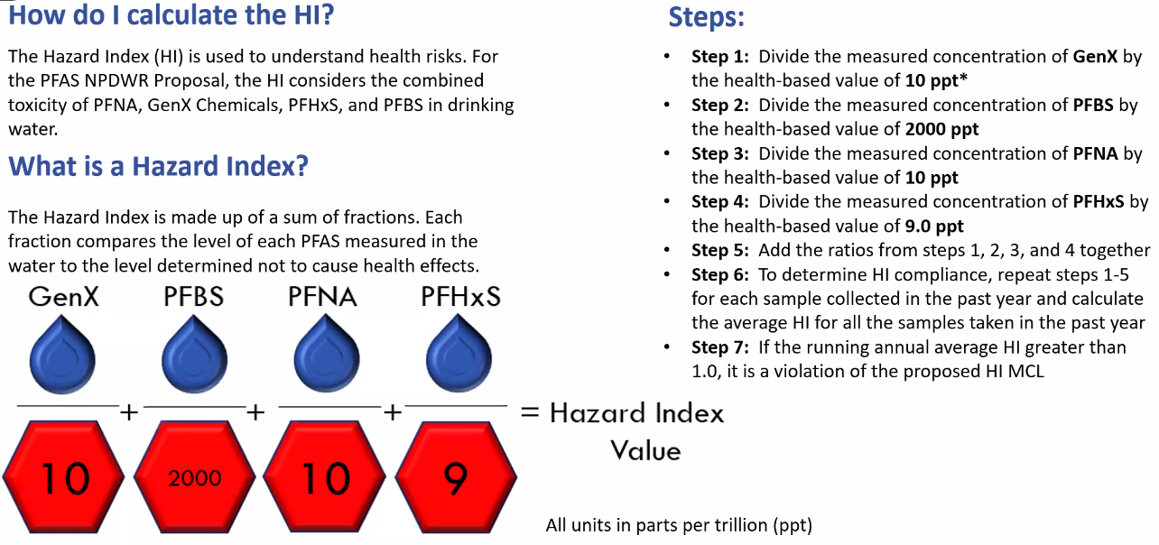

For more detailed information and EPA’s answers to questions about its PFAS proposed Maximum Concentration Level (MCL) and/or Hazard Index (HI), visit:

- EPA’s Proposal to Limit PFAS in Drinking Water March 2023
- https://www.azdhs.gov/documents/preparedness/epidemiology-disease-control/environmental-health/environmental-public-health-tracking/PFAS_Infographic.pdf
- https://www.epa.gov/pfas
- https://azdeq.gov/map

For more information about what ADEQ is doing about PFAS in Arizona, visit: https://azdeq.gov/pfas-resources.

